The Studio

Made by hand.
Made to keep.
Every Scrappy Doll begins as a pile of fabric — quilt offcuts, an old pillowcase, the last good piece of a favorite shirt.
Kanda Kay cuts, pieces, and stitches each doll by hand, finishing with embroidered features and a name only that doll will ever wear. The result is a small, sturdy companion — warm-feeling, washable, and unmistakably one of a kind.
The Process

From scraps
to heirloom.

Gather
Vintage prints, quilt remnants, and meaningful scraps — every doll begins with fabric that already has a story.

Cut & piece
Pattern pieces are hand-cut, then arranged and pieced into a unique combination of color, weight, and texture.

Stitch
Each seam is sewn by hand for strength and character. Faces are embroidered with thread; nothing is glued or printed.

Finish
Hair, jewelry, dresses, and details are added one at a time until a doll has clearly arrived as itself.
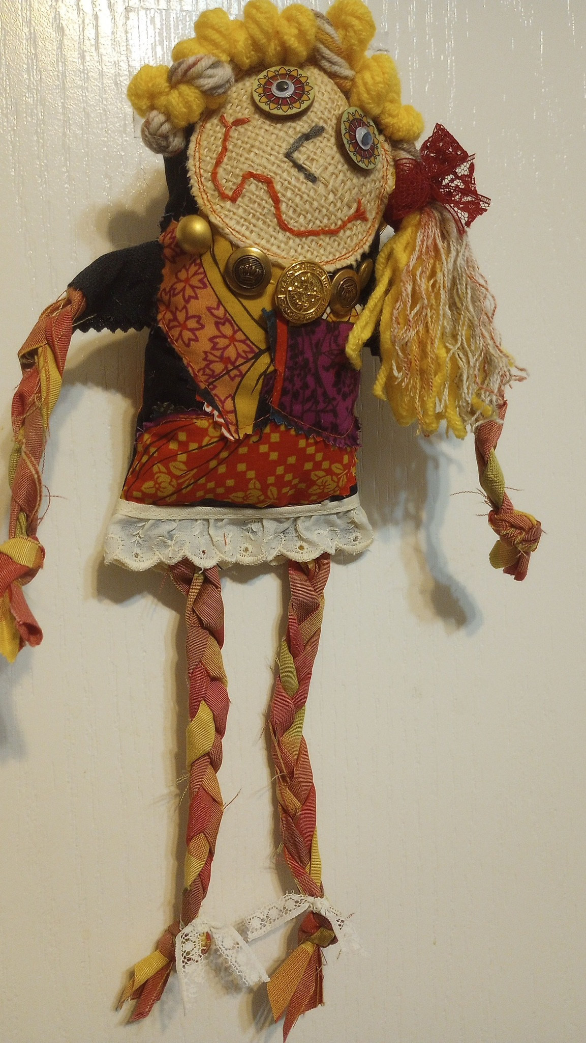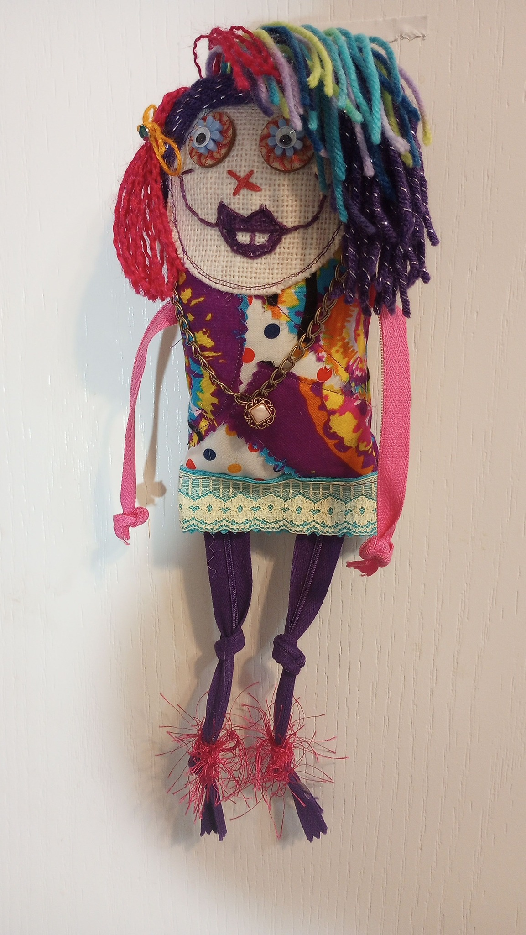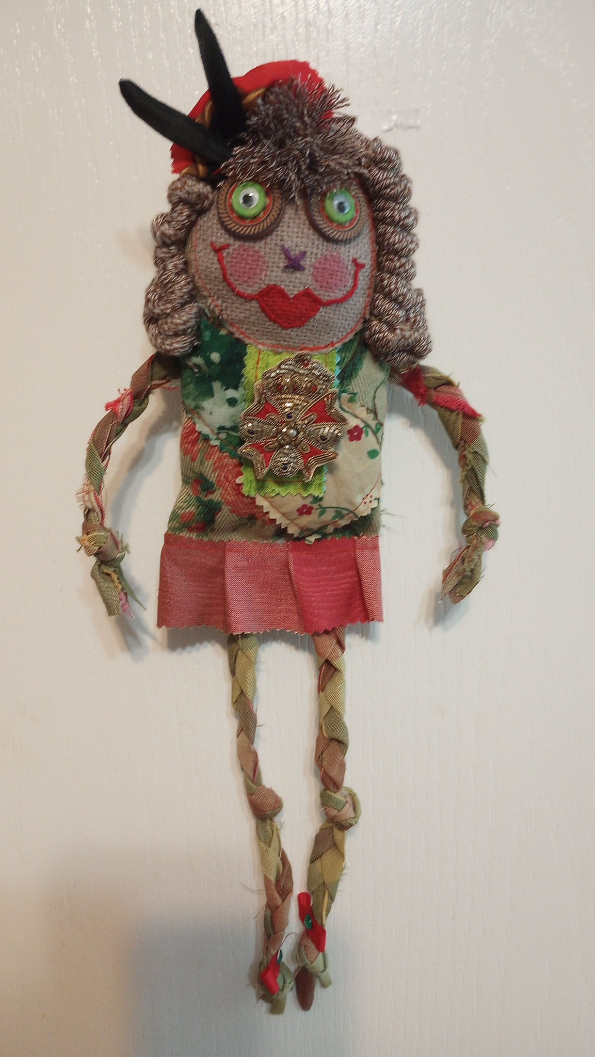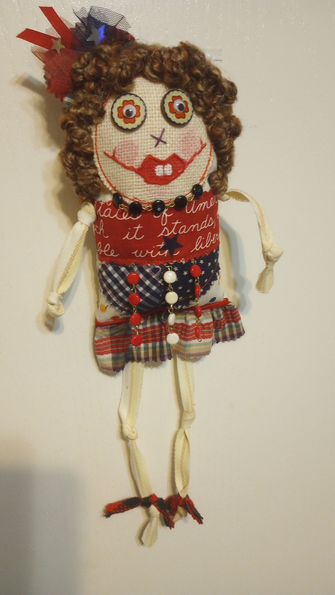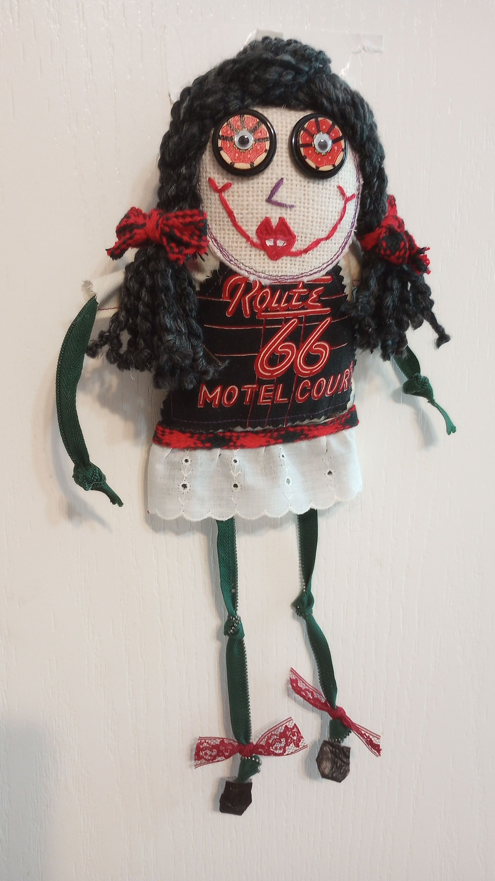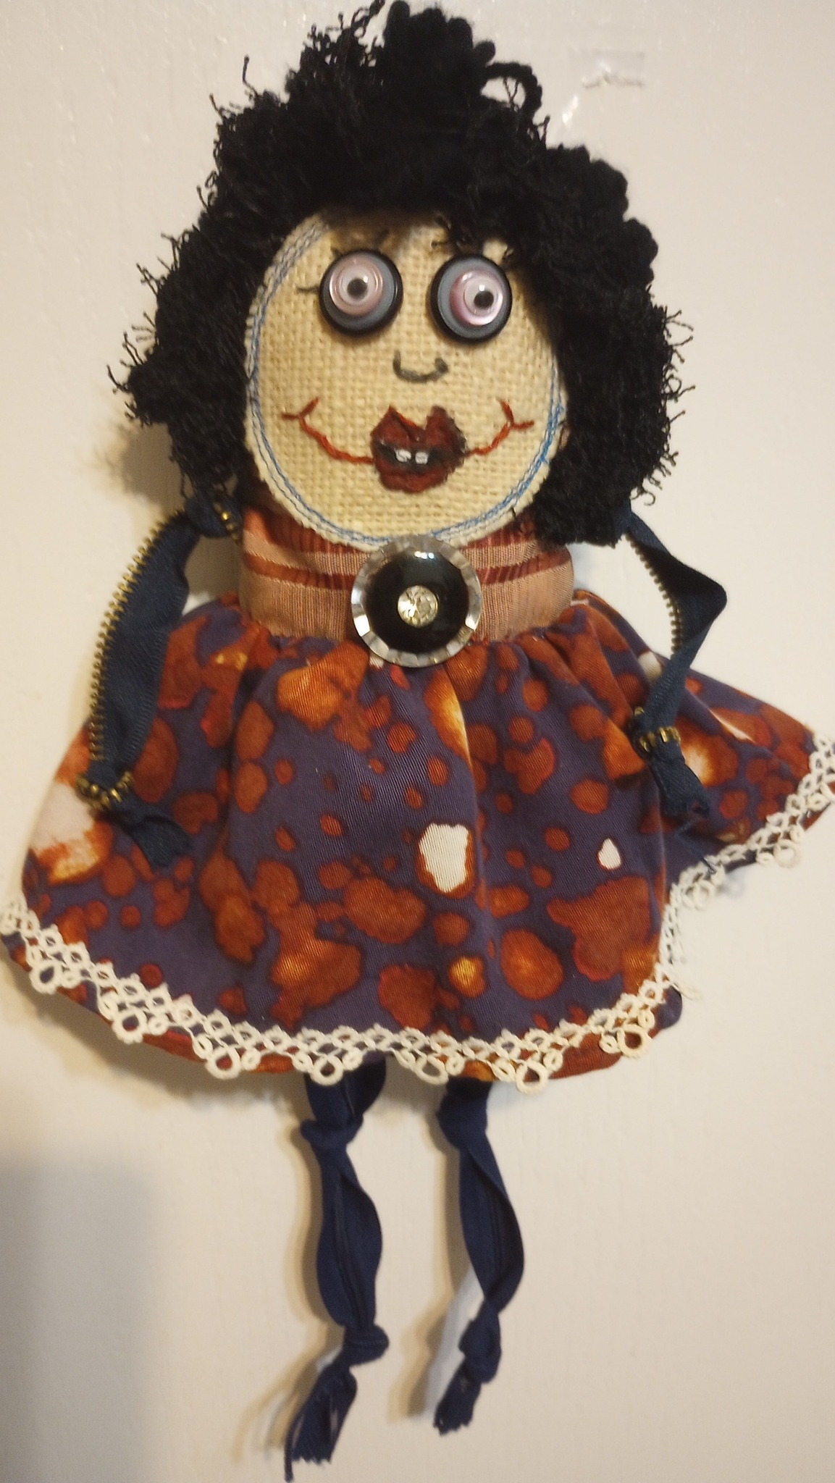
Recent Work

A roster of characters.
A look at recent Scrappy Dolls. New work appears first on Facebook — follow along to see them as they're finished.
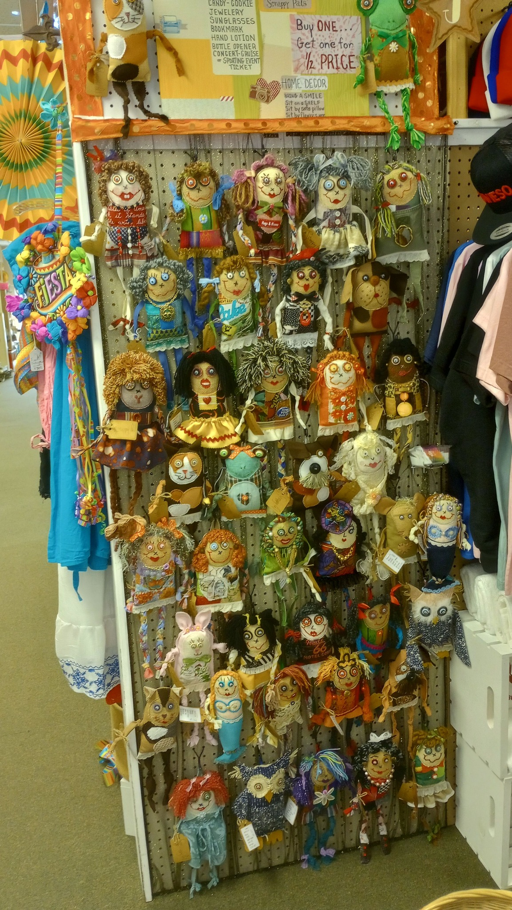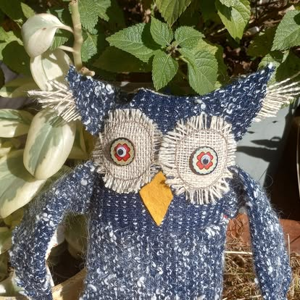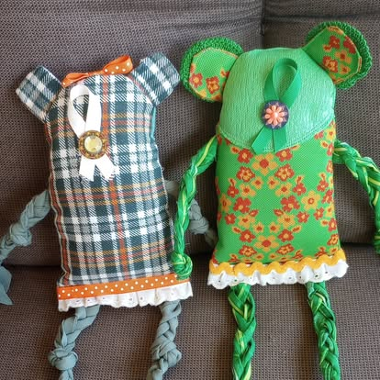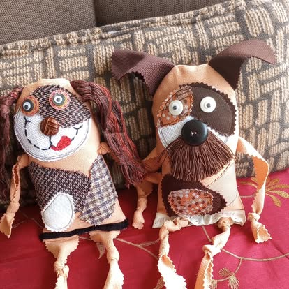
Kind Words

From collectors.
Kanda is an AMAZING artist! She is friendly, professional, very reasonable in pricing, and responsive. We are SO HAPPY with the final product — she captured our furr-babes so perfectly in her whimsical, fun way!
Carrie S.Commissioned pet portraits
I know and recommend this artist — she is amazing and talented. One of a kind.
Albert H.Collector
This artist is magic! I have quite a few pieces, plus one that was specifically commissioned.
Terise B.Collector & commission client
The Tradition

What are scrappy dolls?
Scrappy dolls are handmade cloth dolls stitched from leftover fabric — quilting cottons, vintage prints, worn-out clothing, and remnants too small for anything else but too beautiful to discard. The tradition runs centuries deep. Rag dolls are among the oldest children's toys in existence, with examples found in Roman-era graves dating to the first century AD. In early America, mothers and grandmothers fashioned dolls from household scraps — old dresses, flour sacks, handkerchiefs — because manufactured toys were either unavailable or unaffordable. Appalachian folk dolls, prairie dolls, and Amish faceless dolls all grew from this same impulse: take what you have and make something worth keeping.
What sets scrappy dolls apart from mass-produced toys is the material itself. Every scrap carries a history — a quilt that wore through, a child's outgrown shirt, the last cut from a bolt of fabric a grandmother picked out. The doll becomes a vessel for those stories. No two scrappy dolls look alike because no two fabric piles are the same. The wonky proportions, mismatched prints, and hand-stitched imperfections are not flaws. They are the entire point.
Today, scrappy dolls have become a movement. Online communities — Facebook groups, Pinterest boards, and craft forums — connect thousands of makers who share techniques, trade fabric, and celebrate the deliberate imperfection that makes each doll one of a kind. The craft appeals to experienced quilters looking to use their scrap stash, to parents seeking meaningful handmade gifts, and to collectors drawn to folk art with genuine provenance and personality.
The Craft

Why scrappy dolls endure.

Materials that matter
The best scrappy dolls start with quilter's cotton — sturdy enough to handle stuffing, soft enough to hold and love. Vintage prints, ditsy florals, feedsack reproductions, bold stripes, and novelty fabrics all find their way into the mix. The fabric choices give each doll its character before a single stitch is sewn. Some makers sort scraps by color; others grab from the pile and let the combinations surprise them. Both approaches work because the aesthetic lives in the collision of patterns, not in any single fabric.

Handwork over machine work
Many scrappy doll makers — including Kanda Kay — work entirely by hand. Hand-cutting means every piece follows the curve of the available fabric rather than forcing a rigid pattern. Hand-stitching produces seams with character and strength that hold up to years of handling. Faces are embroidered with thread rather than printed or stamped, giving each doll an expression that could only belong to that one creation. Nothing is glued. Nothing is mass-produced. The process is slow by design.

Sustainability built in
Scrappy dolls are zero-waste craft at its most natural. Quilt offcuts, retired clothing, bolt ends, and fabric remnants all become raw material. Between 1900 and 1920, over five million rag dolls were produced annually in the United States, fueled in part by textile waste from cotton mills. A century later, the same logic holds: fabric that would otherwise sit in a drawer or end up in a landfill becomes a keepsake instead. Every scrappy doll is a small act of reclamation.

The appeal of imperfection
In a market saturated with identical plastic toys, scrappy dolls offer something manufacturers cannot replicate: genuine singularity. The slightly uneven ears, the seam that follows the fabric's grain instead of a laser-cut line, the mismatched buttons — these details are what collectors and gift-givers seek out. A scrappy doll is proof that a human hand made it, and that the person who made it cared more about soul than symmetry. That is why the scrappy doll community continues to grow, and why the best examples are kept for generations.
Frequently Asked

Good questions.
Are dolls available to purchase?
New dolls are announced on the Scrappy Dolls Facebook page as they're finished. Send a message there to ask about what's currently available.
Can a doll be made from my own fabric?
Memory dolls — made from a child's outgrown clothing, a wedding dress, a beloved quilt — are part of what scrappy dolls are best at. Reach out via Facebook to talk through your fabric and what you'd like.
Are Scrappy Dolls safe for children?
Dolls are sewn with sturdy seams and embroidered features (no buttons or small attached parts), and stuffed with fiberfill. They make wonderful keepsakes and play companions for older babies and children.
How do I care for a Scrappy Doll?
Spot clean with a damp cloth and mild soap. For a deeper clean, hand-wash gently in cool water and reshape while damp; lay flat to dry.
How long does it take to make a doll?
It depends on the fabric, the character, and the level of detail. A doll can take anywhere from an afternoon to several days — and each one tells you when it's done.
Stay close

See new dolls
as they're finished.
Follow Scrappy Dolls on Facebook for new work, sneak peeks of what's on the table, and the stories behind the fabric.
Follow on Facebook→
Scrappy Dolls
Handmade cloth dolls by Kanda Kay.
Facebook
© 2026 Scrappy Dolls. Made

